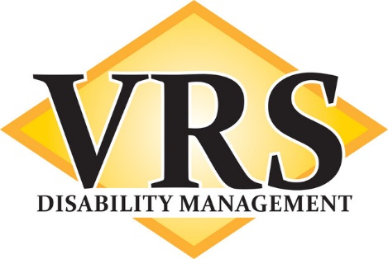

Appreciate the Difference!

ERGONOMIC EVALUATIONS

Keep your employees working!

*Comprehensive ergonomic analysis of a worker’s job duties

*Modifications in the way a worker performs tasks

*Physical changes to the work environment

*Analysis of the workers body mechanics and posture

*Recommendations for adaptive equipment

*Objective, detailed summary report

There is no better way to reduce lost time days than to keep your employees working!

Utilize VRS Ergonomic Evaluations to significantly reduce your indemnity exposures.

For more information or to make a referral, please contact our Director of Sales:

Scott Doyle, email: ScottDoyle@VRSDM.com, cell: 603 717-2023

